Log Analysis Basics – Network-Based Attack Detection Using UFW
Student: Agboola Gboyega Oloyede Course: Advanced Cybersecurity Class Tutor: Mr. Oluwasola Date: 24 October, 2026 GitHub: @David-CEH

Objective
The objective of this lab is to simulate a network-based port scan and demonstrate how to detect it using UFW logs on a Linux system. Students will learn how to launch an HTTP port scan from a Kali Linux (attacker) machine and detect the scan attempts on the victim machine using UFW.

Lab Setup
System Requirements

Role | System | IP address | Tools
Attacker Machine | Kali Linux | 192.168.154.131 | Nmap installed
Target Machine | Ubuntu Linux | 192.168.154.132 | UFW installed

Tools Needed
- nmap (on the attacker machine)
- UFW (on the target machine)

Log Files
/var/log/ufw.log on Ubuntu Server – captures firewall and network-related messages.

UFW Rule Syntax
- Basic allow rule: sudo ufw allow PORT
- Deny a port: sudo ufw deny PORT
- Allow by service: sudo ufw allow ssh
- Allow traffic from an IP address: sudo ufw allow from SOURCE-IP
- Allow a specific port from an IP address: sudo ufw allow from SOURCE-IP to any port PORT
- Delete a rule: sudo ufw delete RULE

LAB TASK: STEPS PERFORMED

Step 1: Simulate a Port Scan
On the attacker machine (Kali), the following command was run.
TARGET-IP = 192.168.154.132
nmap -p 80 192.168.154.132

Step 2: Enable UFW Logging and Analyze the Logs
On the Target machine (Ubuntu), the following commands were run.
1. Install UFW, enable it, and turn on logging:
sudo apt install ufw
sudo ufw enable
sudo ufw logging on
sudo ufw logging high
2. Add a firewall rule to deny HTTP traffic from the authorized test machine. Replace SOURCE-IP with the attacker machine’s IP address:
sudo ufw deny from "SRC=192.168.154.131" to any port 80 proto tcp
3. Reload the firewall rules:
sudo ufw reload
sudo ufw status numbered

4. Monitor UFW log entries for the source IP. Replace SOURCE-IP with the attacker machine’s IP address:
sudo tail -f /var/log/ufw.log | grep "SRC=192.168.154.131"

Step 3: Find the evidence in the logs (Ubuntu)
sudo grep "UFW BLOCK" /var/log/ufw.log | grep "SRC=192.168.8.131 " | tail

5. Evidence

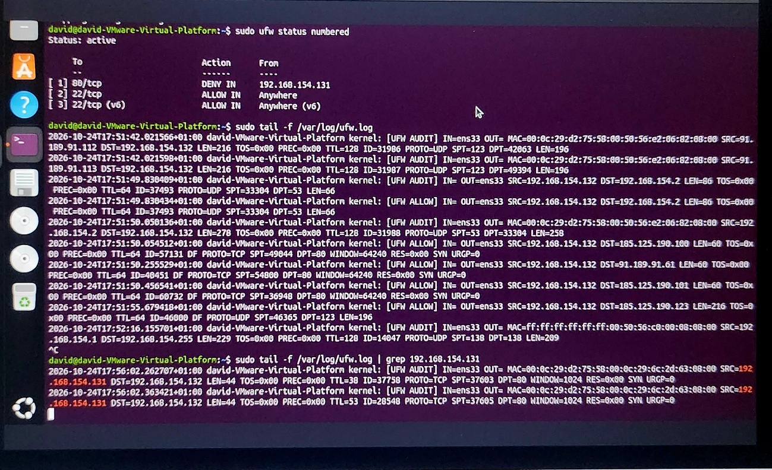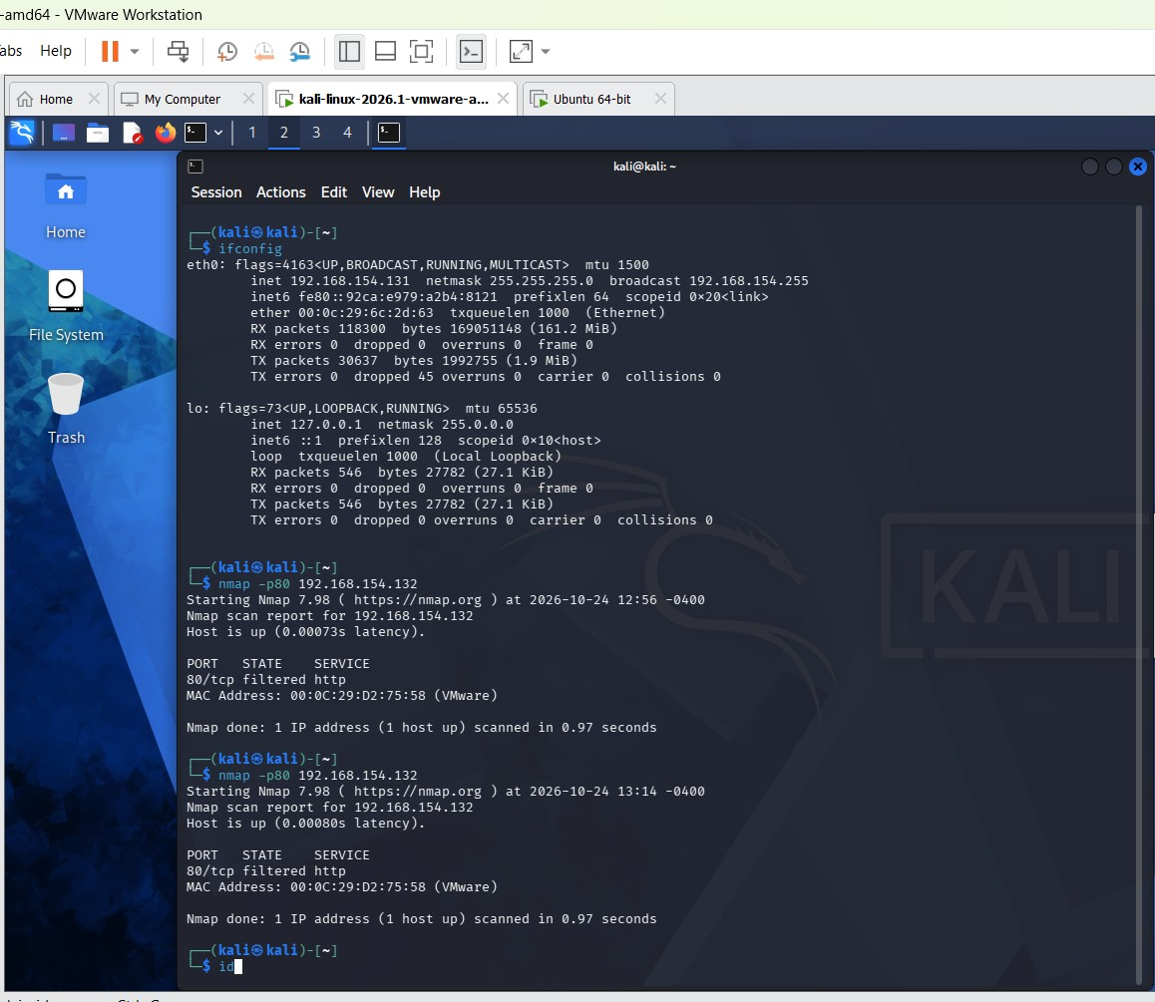

What The Important Fields Mean
- SRC=192.168.154.131: The IP address of the system that sent the packets.
- DST=192.168.154.132: The Ubuntu machine receiving the packets.
- DPT=80, The destination TCP ports targeted by the packets.
- PROTO=TCP: The packets use the Transmission Control Protocol.
- SYN=1: The packets have the SYN flag set, which is normally used to initiate a TCP connection.
- UFW AUDIT: A firewall-related log prefix. It does not, by itself, establish that the packet was denied.

Findings
The Ubuntu firewall was enabled, and UFW logging was configured to the high level. The firewall status showed a deny rule for TCP port 80 from source IP address 192.168.154.131.
The log entries showed TCP SYN packets originating from 192.168.154.131 and targeting the Ubuntu host at 192.168.154.132. The visible destination port was 80.

Conclusion
The screenshot demonstrates that UFW logging is enabled and records TCP traffic associated with possible port-scanning activity. However, the visible UFW AUDIT entries do not independently confirm that all the packets were blocked. Further examination of UFW BLOCK entries is required to verify successful firewall blocking.

Recommendation
Continue monitoring firewall logs, verify the configured deny rules, and record clear evidence showing the source IP, targeted port, timestamp, and explicit UFW BLOCK prefix for any traffic confirmed as blocked.

